Legal Analytics: Presentation-1
Geethanjali Manoj Kumar 201IT220

NOTE: This document is heavily plagiarism as it is just a collection of data and information for understanding concepts before moving on to the rest of the project

Goal: Understand the shared tasks, and literature survey, and understand the info to be able to define the problem statement.

Material Provide: https://sites.google.com/view/legaleval/home#h.emjo6i560q71

Goal/Motivation of the shared tasks from the above link:
In populous countries (e.g., India), pending legal cases have grown exponentially. Due to the nature of the legal domain, it may not be possible to automate the entire judicial pipeline completely; nevertheless, many intermediate tasks can be automated to augment legal practitioners and hence expedite the system. However, legal texts are different from commonly occurring texts typically used to train NLP models which make it difficult to apply existing NLP models and techniques directly, which calls for the development of legal domain-specific techniques. We are proposing 3 shared subtasks which will act as building blocks in developing legal AI applications.^{[1]}

Pre trained transformer models

3 Shared Subtasks:
- Rhetorical Roles Prediction (RR)- statistics and type of data
- Legal Named Entities Extraction (L-NER)
- Court Judgement Prediction with Explanation (CJPE)
RR
Legal documents are often long and unstructured and have to be segmented into semantically coherent segments called as rhetorical roles.
There are 7 RRs: identifying the case, establishing the facts of the case, arguing the case, history of the case, arguments, ratio decidendi and final decision.
So the model must go line by line and link each sentence to a specific RR, the tags used in the base paper are: Preamble, fact, Arg. by respondent, issue, none, ratio, ruling by present court, ruling by lower court, arg. By petitioner, analysis, precedent relied upon, precendent not relied upon, the bases paper uses 12 rr labels and a NONE label.

This task is a sequential sentence classification with single label multiple classes.
Challenges:
- Legal documents are extremely long (100-1000 pages)
- Usage of lexicons: commonly occurring words might have different legal connotations.
- Manually typed documents: spelling and grammatical errors
- Deficiency of annotated corpora
- Unstructured
What the base paper has implemented:
- The problem is approached as if it was a multiclass sequence prediction problem.
- CRF (conditional random field) model was used
- F1 score metric is used
L-NER
For all NLP based projects we have publicly available standard NERs (Named Entity Recognition), but when it comes to Legal NER there are several unrecognized entities and a separate NER specific to Legal jargon has to be developed.
Some sample entities we notice in legal documents are: names of petitioner, respondent, court, statute, provision, precedents, etc
NER is used for information extraction that searches and segmentizes named entities in text. Named entities are defined as proper nouns that refer to specific individuals, places, organizations, or things. NER is a challenging task because named entities can vary in length and can appear in different forms.
A list of legal entities that are commonly covered: https://github.com/Legal-NLP-EkStep/legal_NER
- F1 score metric is used
Base paper: https://arxiv.org/pdf/2211.03442.pdf
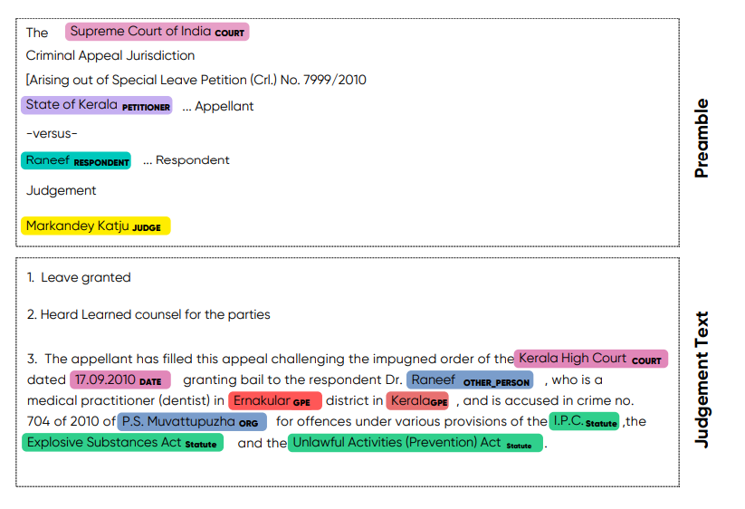
The end goal behind this work is to enable the development of other legal AI applications that consume automatically detected legal named entities from judgment texts.
Base paper uses 2 NER models/architecture and compares them:
- a transition-based dependency parser (Honnibal and Johnson, 2015) on top of the transformer model: Roberta-base mode, InLegalBERT using Spacy library
- a fine-tuning based approach which adds a single linear layer to the transformer model and fine-tunes the entire architecture on the NER task: Roberta-base, InLegalBERT, legalBERT using TNER library
- 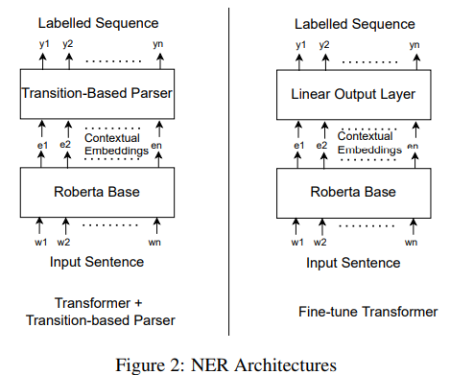

CJPE
Predict an expected decision and provide an explanation for the same. Helps expedite the legal system. The base paper provides a binary outcome: accepted or denied, along with an explanation of the decision. This subtask hence is further broken down into two smaller sub tasks:(1)Court Judgement Prediction (2)Explanation for predicted judgement. The evaluation for judgment prediction (binary classification) will be done using the standard F1 score metric, and for the explanation sub-task, we will be using BLEU, METEOR, and ROUGE scores (Malik et al., 2021b) for evaluating the machine explanations with respect to the gold annotations.

Base paper: https://aclanthology.org/2021.acl-long.313/

More Information

A transformer plus transition-based parser is a combination of two types of models used for natural language processing (NLP). The transformer model is a type of neural network architecture that is designed to process sequences of tokens, such as words or characters, and is often used for tasks such as language modeling and machine translation. The transformer architecture is particularly well-suited to capture long-range dependencies and contextual information in text.

A transition-based parser, as I mentioned earlier, is an algorithm that builds a parse tree for a sentence by applying a series of transition actions. These parsers typically use hand-crafted features to guide the parsing decisions.

The combination of a transformer model and a transition-based parser aims to leverage the strengths of both models. The transformer model can provide rich contextual information to the transition-based parser, while the transition-based parser can use this information to make more informed parsing decisions. This approach has shown promising results in recent research on dependency parsing, which is the task of analyzing the syntactic structure of sentences.

Fine-tuning a parser refers to the process of taking a pre-trained parser, which has been trained on a large corpus of text data, and adapting it to a specific task or domain by further training it on a smaller, domain-specific dataset. The goal of fine-tuning is to improve the performance of the pre-trained parser on the task at hand by leveraging the knowledge it has acquired from the large corpus of text data it was originally trained on.

The process of fine-tuning a parser typically involves the following steps:

- Selecting a pre-trained parser: The first step is to select a pre-trained parser that is suitable for the task at hand. For example, if the task is dependency parsing, then a pre-trained parser that has been trained on a large corpus of text data for dependency parsing may be selected.

- Preparing the training data: The next step is to prepare a smaller, domain-specific dataset for training the parser. This dataset should be representative of the domain in which the parser will be used, and should include examples of the parsing task that the parser is being fine-tuned for.

- Fine-tuning the parser: The pre-trained parser is then further trained on the domain-specific dataset using a technique called transfer learning. During this process, the parameters of the pre-trained model are updated based on the new data. The fine-tuning process typically involves adjusting the learning rate, the number of training epochs, and other hyperparameters to optimize the performance of the parser on the task at hand.
- Evaluating the fine-tuned parser: Finally, the performance of the fine-tuned parser is evaluated on a held-out dataset to assess its accuracy and generalization to new data.

Fine-tuning a parser can be a powerful technique for adapting pre-trained models to specific domains or tasks, and has been shown to improve the performance of parsers on a variety of NLP tasks.

RoBERTa (Robustly Optimized BERT pre-training approach) base is a pre-trained transformer-based neural network model for natural language processing (NLP). It is based on the BERT (Bidirectional Encoder Representations from Transformers) model architecture, but with several improvements to the pre-training process and the model architecture itself. RoBERTa was developed by Facebook AI Research and released in 2019.

The RoBERTa base model has 12 layers, 768 hidden units, and 125 million parameters. It is trained on a large corpus of text data using an unsupervised pre-training approach called Masked Language Modeling (MLM), which involves randomly masking out tokens in the input text and training the model to predict the masked tokens based on the surrounding context. RoBERTa also incorporates other pre-training objectives such as next sentence prediction and sentence order prediction, which helps to improve its performance on downstream NLP tasks.

RoBERTa has been shown to achieve state-of-the-art performance on a wide range of NLP tasks, including question answering, text classification, and named entity recognition. The RoBERTa base model is typically used as a starting point for fine-tuning on specific downstream tasks, where it can be further optimized for specific domains or applications.

